4th QUARTERLY PROGRESS REPORT

PROJECT TITLE: CB2-CCCD Project, Vanuatu
PROJECT NUMBER: 17A364
Applicable Output(s) from the SRPD (2018-2022):
Outcome 1: Climate Change disaster resilience and environmental protection
Output 1.3: Solutions developed at National and sub-national management for sustainable management of natural resources and wastes
_____________________________________________________________________________________
PART 1: DESCRIBE THE KEY RESULTS ACHIEVED IN THIS QUARTER:
The Vanuatu CB2-CCCD Project is crucial to assist the Government of Vanuatu in this critical area at the national level, seeking to harmonize existing information systems, integrate internationally accepted measurement standards and methodologies, and develop the capacity for a more consistent environmental reporting both at national and global level. The project will also support activities to strengthen the coordination between key sectors to address biodiversity, climate change and land degradation issues at systemic and institutional levels.
In brief during quarter 4 the project had made some progress towards the main goals of the project. Environmental information awareness through the development of the project communication strategy which include the communication materials such as booklets, posters, pull-up banners, factsheets, t-shirts, etc for the dissemination of environmental information. The development of the project twitter and Skype accounts also signifies the important of marketing the project to a wider audience. The recruitment of the international and local consultant for a period of 6 months commencing 2nd of January 2018 to undertake the activities under outcome 1,2 & 3.
Finally the project was fortunate to conduct its first ever project board meeting which resulted in a lot of constructive discussions and decisions made towards the successful implementation of the project.

RESULTS RESOURCE FRAMEWORK QUARTETLY PROGRESS (**In some projects, Outputs in Project Documents are equivalent to Activity Results level in ATLAS)
EXPECTED ATLAS ACTIVITY RESULTS | ACTIVITY RESULTS INDICATORS | BASELINE | ANNUAL TARGETS | OUTPUTS INDICATORS RESULTS | EVIDENCE (SOURCE, LINK)
Outcome 1  Improved management information system for the global environment | No. of inventories undertaken, and reporting obligations, and information needs identified. | - There is limited unified set of standards, norms and procedures to collect data, conduct observations and make sampling  - No data architecture is in place to structure environmental information at national level in Vanuatu  - Limited technology is in place to support data management for an effective sharing of environmental information  - Information is shared on an ad-hoc basis among institutions mostly on an informal basis | Draft inventory of environmental data set, along with reporting obligations and information needs. | Progress Keys:  On Track, Achieved or Progress  Status:  On track  Report Results Achieved against Outcome 1 Indicator(s):  30% has been achieved during quarter 1 & 2 on improved management information system for the global environment.  1. Vanuatu environmental  Information mapped out through scooping with some of key government stakeholders as indication for the early stages of environmental information management set up.  2. Currently out of the 6 activities for 2nd quarter 17 to 20% rating of activities has been carried out for each of the activities.  3. During quarter 3, the TOR for the international and local consultant has been finalized and awaits the process of procurement through the government system | Finalized contract and  Terms of Reference (TOR)  - International Consultant  - Local Consultant  (The local and international consultant will be contracted for a period of 6 months to undertake the activities for quarter 1,2,3 & 4 during quarter 1 of 2018)
Outcome 2  Strengthened individual capacities for monitoring and evaluation of the global environment. | No. of training analyses undertaken, no. of training programme development, and no. of training activities completed. | - There is no training progr amme for public administrators on environmental information management  - 0  - Limited environmental information is used to develop policies and programmes | 2 training needs analyses undertaken, 2 training programme developed, and 2 training activities conducted for: (i) new and improved data and information collection and measurement methodologies; and (ii) analytical skills to analyze/ measure environmental trends. | Progress Keys:  On Track, Achieved or Progress  Status:  Not applicable for the reporting period  Report Results Achieved against Outcome 2 Indicator(s):  Not applicable for the reporting period | Finalized contract and  Terms of Reference (TOR)  - International Consultant  - Local Consultant  (The local and international consultant will be contracted for a period of 6 months to undertake the activities for quarter 1,2,3 & 4 during quarter 1 of 2018)
Outcome 3  Improved decision-making mechanisms for the global environment institutionalized. | Status of working group structure, institutional mandates, and key opportunities. | - Existing mechanisms are operational, however inter-sectorial coordination is limited.  - Existing action plans are operational but are focused on specific sectors with limited multi-sectoral approaches |  | Progress Keys:  On Track, Achieved or Progress  Status:  Report Results Achieved against Outcome 3 Indicator(s):
OVERALL OUTPUT PROGRESS RESULTS (contributes to ROAR Section B and IWP EA) |  |  |  | Progress Keys:  On Track, Achieved or Progress  Status:  On track  Report Results Achieved against Output Results Indicator (s):  The local and international consultant TOR has been completed and approved.  Contracts have been finalized and signed by both the local and international consultant | Finalized contract and  Terms of Reference (TOR)  - International Consultant  - Local Consultant  (The local and international consultant will be contracted for a period of 6 months to undertake the activities for quarter 1,2,3 & 4 during quarter 1 of 2018)

PART 2: PARTNERSHIP
Implementing Partner (IP) and Focal Point Contact (Title, email, fax, phone, address) | Type of Partnerships/Role | Duration of Partnership | Progress of Deliverables from Partnership (**)
Vanuatu Department of Environmental Protection & Conservation  Focal Point: Donna Kalfatak, Principal Conservation & Biodiversity Officer, Biodiversity Division  Email: dkalfatak@vanuatu.gov.vu | Oversee the implementation of the project in Vanuatu | 3 years | Provision of office space for projects, use of vehicle, operation and amenities

**Describe the progress of the key assumptions and expected results achieved by partners that were critical for the identified results
PART 3: RISK and ASSUMPTIONS
Update the Risk Log on this section (This can be updated directly in ATLAS).
Risk | Mitigation Action | Timeframe | Mitigation Action Progress
Availability of key government stakeholders during project meetings/workshops/consultations | Involve in DEPC weekly/monthly/quarterly /ad hoc meetings | Quarter 2,3 &4 | On-going
Vanuatu is prompt to natural disasters (Cyclone season ) | Possibility of drafting a disaster risk management plan | Quarter 4 & Quarter 1 | On-going draft
New information is not used and stays stored in computers within organizations | Draft Environmental data guideline has been developed in order to address sharing agreements  Draft MOU underway | Quarter 4 | Data guideline draft has been finalized  Draft finalized 1st quarter of 2018
Political will to provide environmental government organizations with the necessary resources to sustain the environmental data collection, storage and reporting
Communications and national reports are not submitted on time
Project activities and resources do not translate in increasing the capacity of key organizations to provide better environmental information
New standards, norms and procedures are identified but might not be adopted by the government
Lack of relevant expertise in local market may result in delay of required outputs and distortion of targeted deadlines
Acquire inadequate hardware and develop an IT architecture that is not addressing the data sharing needs
Political will to agree sharing data among government and non-government organizations
The in-service training system for public servants might not be interested in integrating into its catalogue the training curricula developed with the support of the project
No interest in better integrating environmental information in government decision-making
No interest from decision-makers to use better environmental information
Unclear approval mechanism for an inter-sectorial coordination body and unwillingness to participate in the inter-sectorial coordination body
Limited participation of government in improving the implementation of MEAs

PART 4: KNOWLEDGE MANAGEMENT AND COMMUNICATION
In terms of communication, the project is fortunate to develop its own communication strategy detailing the types of communication materials such as booklets, posters, pull-up banners, factsheets, brochures to highlight the importance of environmental information.
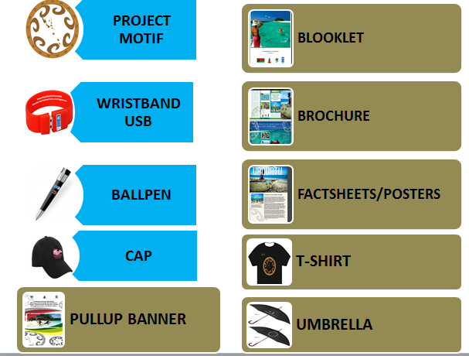

Project Twitter and Skype account
https://twitter.com/vanuatu_cb2
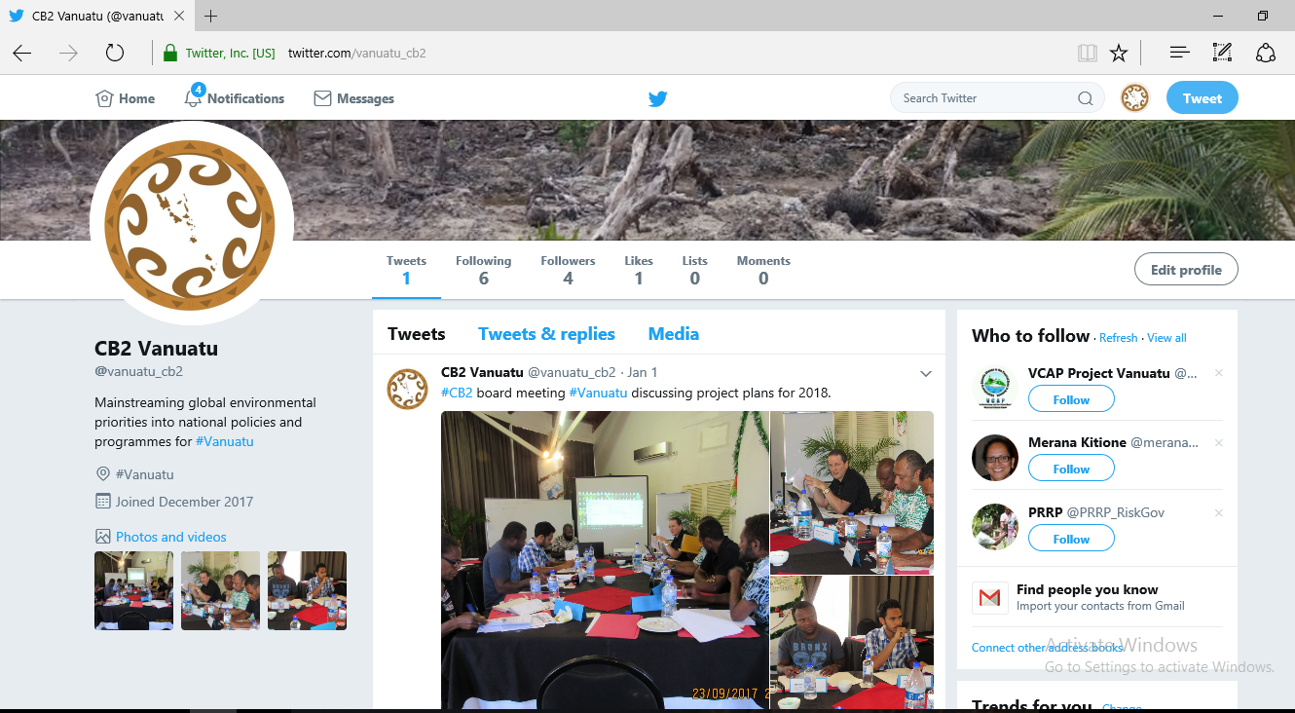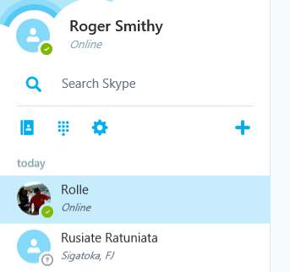
Skype Account

Website link
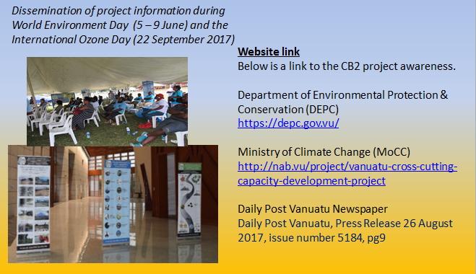
Information Technology (IT) Equipment
Below are list of IT equipment purchase for environmental data management, dissemination purposes and collection of environmental information/data procured during quarter 2, 3 & 4.
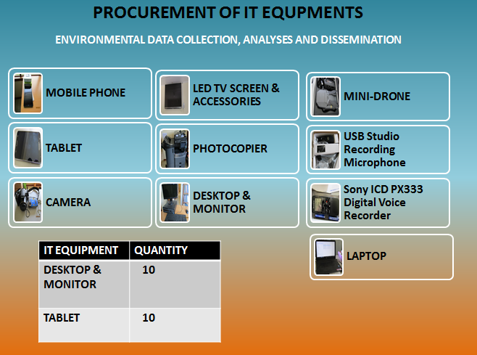
In summary the IT equipment highlight under the communication and management section is basically to build up to activity result 1. As this is part of the whole environment information management system that the project intends to establish at the end of the project. So therefore the establishing of the environmental information management system have initiated through the setup of laptops, computers and so forth.

Establishment of project board meeting
The project was able to conduct its first project board meeting dated 21st December 2017. The board members discuss and provide consensus management decisions for the project in terms of the approval work plans, budgets and the challenges and issues face towards the implementation of the project.
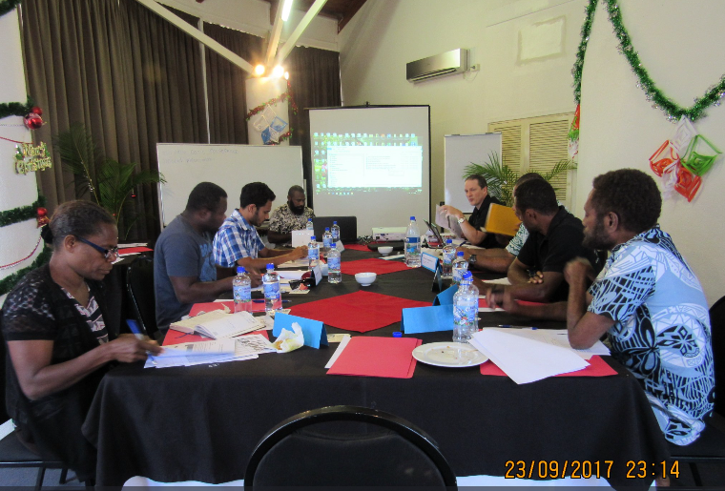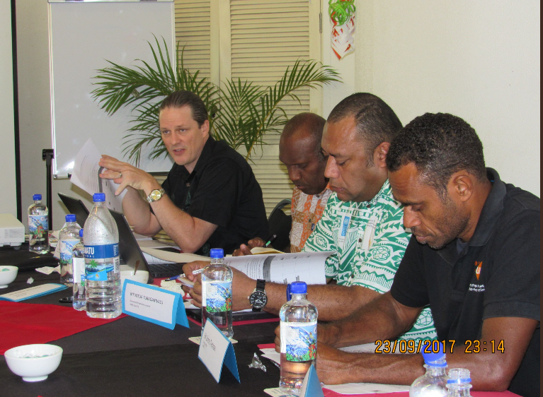

PART 5: KEY LESSONS LEARNT AND CHALLENGES
Budget:
Each of the advance releases must be 80% utilized before requesting of next advances
Board Meeting:
The project was fortunate to conduct its first ever project board meeting in which a lot of constructive discussions and decisions been made for the successful implementation of the project
Project Extension:
The duration is a 3 year project and due to lack of capacity and institutional memory, is the main cause of delay and thus starting the project in 2017. Initially the project as planned should begin in 2016. There during the project board meeting as agree for a possible one year extension with no cost.

PART 6: SUSTAINABILITY AND SCALING UP
**This question is only applicable if project is reporting on its final quarter.
Describe how the project have used relevant national systems to sustain and scale up the results achieved. Describe how the national capacities have been strengthened through this project and how national ownership have been realized.

PART 7: QUARTERLY FINANCIAL REPORT
Activity and duration |  |  | Authorised Amount | Actual Project Expenditure | Expenditures accepted by Agency | Balance | New Request Period & Amount (USD) | Authorised Amount (VUT) | Outstanding Authorised Amount (VUT)
 | UNDP coding |  |  | 01/10/2017-31/12/2017 |  |  | 01/01/2018 - 31/03/2018 |  | Date
 | Account Code | Fund | A | B | C | D = A - C | E | F | G = D + F
1. Outcome 1: | Improved management information system to measure achievements towards global environmental objectives
International Consultant | 71200 | 62000 | 1,549,887 |  | - | 1,549,887 |  | - | 1,549,887
Local Consultant | 71300 | 62000 | 783,627 |  | - | 783,627 |  | - | 783,627
Contractual Services - Individual | 71405 | 62000 | (385,531) |  | - | (385,531) |  |  | (385,531)
Travel | 71600 | 62000 | - |  | - | - |  |  | -
Miscellaneous Expenses | 74500 | 62000 | 20,000 |  | - | 20,000 |  | - | 20,000
IT Equipment | 72800 | 62000 | (1,506,550) |  | - | (1,506,550) |  |  | (1,506,550)
Printing and publications | 74210 | 62000 | (94,985) |  | - | (94,985) |  |  | (94,985)
Training, Workshops & Meet | 75709 | 62000 | (48,643) |  | - | (48,643) |  |  | (48,643)
Office Supplies | 72500 | 62000 | 117,067 | 315,000 | 315,000 | (197,933) |  | - | (197,933)
Printing and publications | 74210 | 62000 | (305,556) |  | - | (305,556) |  |  | (305,556)
2. Outcome 2: | Strengthened individual capacities to monitor and evaluate impacts and trends on the global environment.
International Consultant | 71200 | 62000 | 1,549,887 |  | - | 1,549,887 |  | - | 1,549,887
Local Consultant | 71300 | 62000 | 783,627 |  | - | 783,627 |  | - | 783,627
Contractual Services - Individual | 71405 | 62000 | 687,327 | 421,908 | 421,908 | 265,419 |  | - | 265,419
Travel | 71600 | 62000 | - |  | - | - |  |  | -
Miscellaneous Expenses | 74500 | 62000 | - |  | - | - |  |  | -
Office Supplies | 72500 | 62000 | 73,771 |  |  | 73,771 |  |  | 73,771
Training, Workshops & Meet | 75709 | 62000 | 338,850 |  | - | 338,850 |  |  | 338,850
Office Furniture | 72220 | 62000 | (84,360) |  | - | (84,360) |  | - | (84,360)
3. Outcome 3: | Improved decision-making mechanisms for the global environment institutionalized
International Consultant | 71200 | 62000 | 1,549,887 |  |  | 1,549,887 |  | - | 1,549,887
Local Consultant | 71300 | 62000 | 783,627 |  |  | 783,627 |  | - | 783,627
Contractual Services - Individual | 71405 | 62000 | 652,449 | 421,908 | 421,908 | 230,541 |  | - | 230,541
Travel | 71600 | 62000 | - |  | - | - |  |  | -
Miscellaneous Expenses | 74500 | 62000 | - |  | - | - |  |  | -
Office Supplies | 72500 | 62000 | 63,078 | 315,000 | 315,000 | (251,922) |  | - | (251,922)
Training Workshops and Conferences | 75705 | 62000 | 185,702 |  | - | 185,702 |  | - | 185,702
Promotional Materials and Dist | 74215 | 62000 | (44,000) |  |  |  |  |  | -
Office Furniture | 72220 | 62000 | (42,667) |  | - | (42,667) |  |  | (42,667)
4. Project Management Unit (PMU)
Contractual Services - Individual | 71405 | 62000 | (338,240) |  | - | (338,240) |  | - | (338,240)
Miscellaneous Expenses | 74500 | 62000 | 189,704 |  | - | 189,704 |  |  | 189,704
Office Furniture | 72220 |  | (6,949)
Office Supplies | 72500 | 62000 | (38,854) |  | - | (38,854) |  |  | (38,854)
UNDP Cost-Recovery Charges/ Bank Charges | 74599 | 62000 | 10,822 | 8,780 | 8,780 | 2,042 |  |  | 2,042
Training Workshops and Conferences | 75705 | 62000 | (13,000) |  |  |  |  |  | -
Total |  |  | 6,429,978 | 1,482,596 | 1,482,596 | 5,011,331 | - | - | 5,011,331

PART 8: LIST OF EVIDENCE PROVIDED AS ANNEX
Example 1: If training has been done for youths or women you need to have evidence via list of participants disaggregated by gender, age and signed by participants (as per workshop participant list etc.)
For Workshop reports the following are required; author, date of report and title. A copy of the final report needs to be submitted.

PART 9: QUALITY ASSUARANCE
PROJECT MANAGER:  Name:  Signature: | REVIEWED & APPROVED:  TEAM LEADER  Name:  Signature | VALIDATION ON RBM, EVIDENCE BASED REPORTING& CLEARANCE FOR CORPORATE UPDATE OF RESULTS (ATLAS &CPS)  IRMU  M&E Analyst:  Signature:

